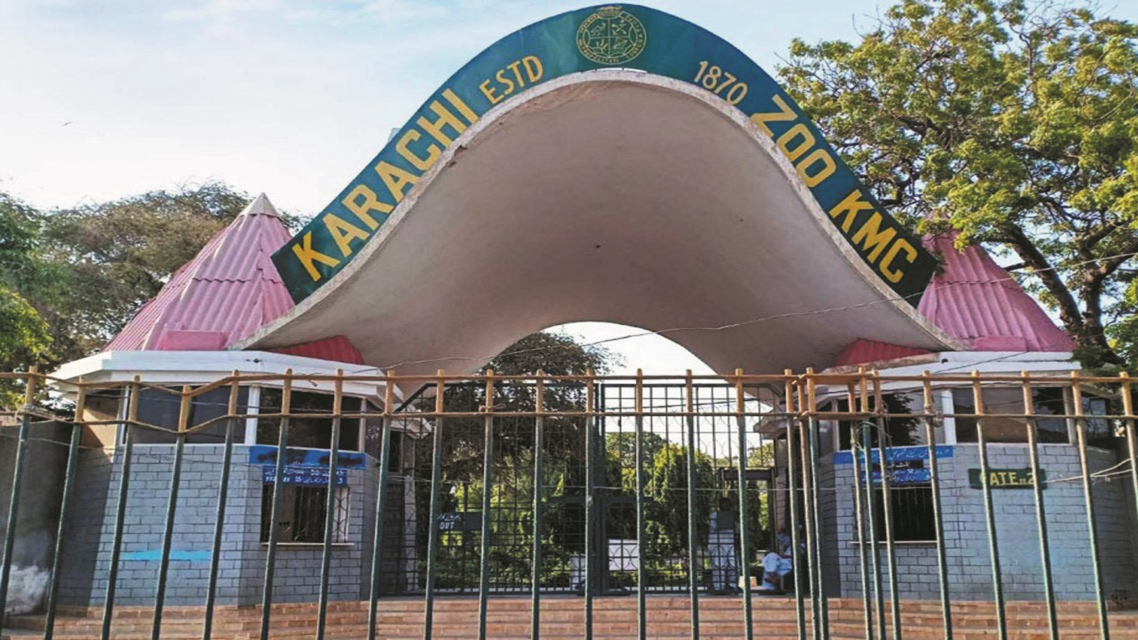

About Karachi Zoo Park

What is Karachi Park Zoo? and where is located established? The Karachi Zoo is one of the oldest and most well-known zoos in Karachi, Pakistan. It is located in the city center and serves as a major recreational

and educational spot for residents and visitors Karachi Zoo, also known as Gulshan-e-Iqbal Zoo, is located at Ayub National Park, Karachi, Pakistan. The zoo is situated in a central area of the city,

making it easily accessible for locals and tourists alike The Karachi Zoo was officially established in 1878, making it one of the oldest zoos in Pakistan.

Opening & Closed Timings

2025 Open daily from 8:00 AM to 6:00 PM

The last admission to Karachi Zoo (Gulshan-e-Iqbal Zoo) is typically around 5:30 PM, as the zoo closes at 6:00 PM.

The zoo is open to families everyday 8:00 AM To 5:30 PM.

The Karachi Zoo (Gulshan-e-Iqbal Zoo) does not have specific "ladies-only" days or timings that are regularly announced. However, many zoos worldwide, including in Pakistan, occasionally host special events or days with discounts or activities focused on women or families,

but these are typically on a case-by-case basis.

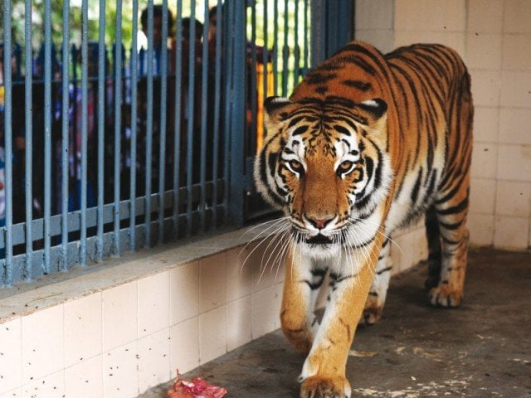

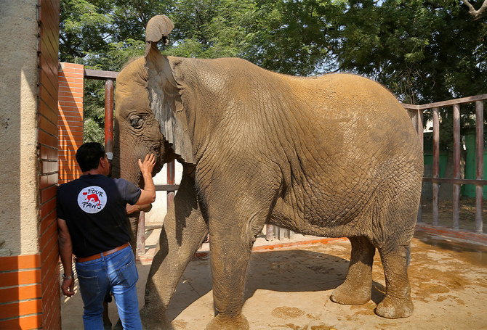

Animals List

The Karachi Zoo (also known as Gulshan-e-Iqbal Zoo) is home to a variety of animals, with around 700-800 animals across 100-150 species. 0 Notable exhibits include:

Lions

Puma

tigers

Zebra

Crocodiles

Snakes

Tortoise

Deer

Monkeys

Address & Contact

Address: The zoo is located in the central area of Karachi, near Ayub National Park. For questions related to visiting, opening times, directions, accessibility, or other general information, you can visit their [Support Centre](https://www.kmc.gos.pk).

Email: For specific enquiries <br>you can fill out the contact form available on their (info@kmc.gos.pk).

Phone:For urgent enquiries, you can call their Supporter Contact team at +92 21 99244445.

For the most accurate and up-to-date information, it's recommended to visit the [official Karachi Zoo Gulshan-e-Iqbal website](https://www.kmc.gos.pk).